**Programming Concepts and UI Design:**

1. **Frontend Development:** Frontend development involves creating the user interface (UI) that users interact with when accessing the EduScan platform. This includes designing and implementing web pages where users can view educational content, sign in or sign up, navigate different sections of the website, and interact with various features.

* Designing the layout and structure of web pages using HTML.
* Styling the UI elements to create an attractive and user-friendly interface using CSS.
* Adding interactivity and dynamic behavior to the UI using JavaScript.

**Sign in Page:**

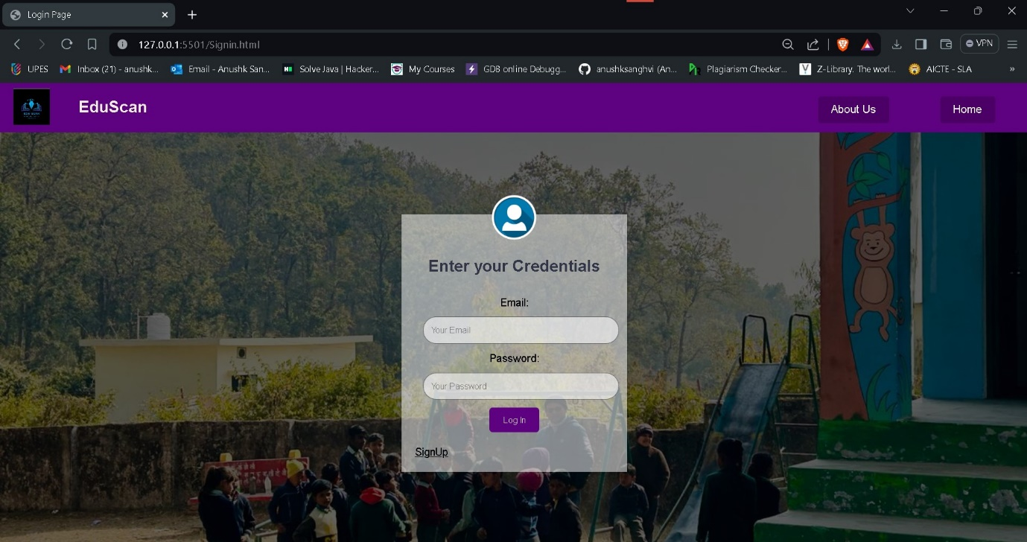

**Sign Up page:**

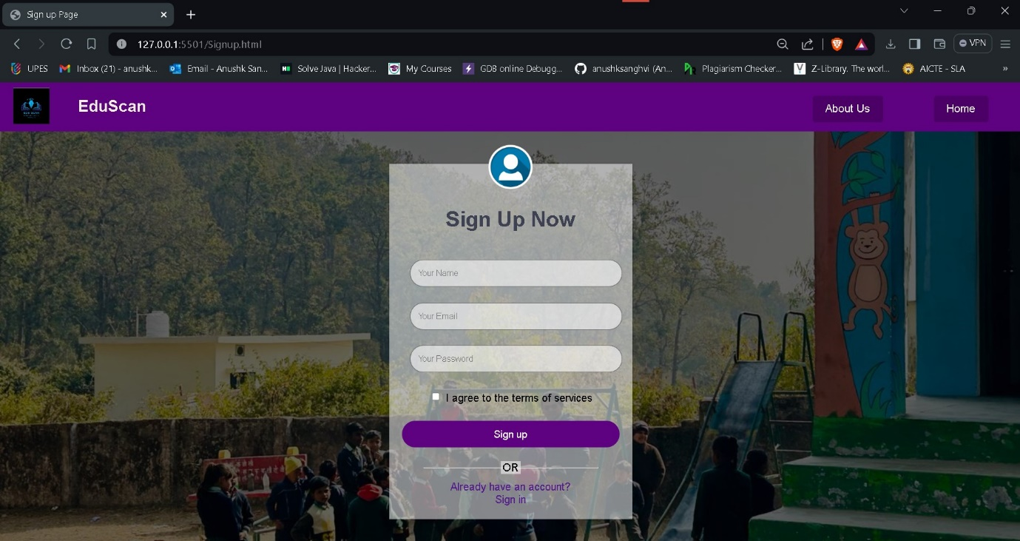

**Landing Page:**

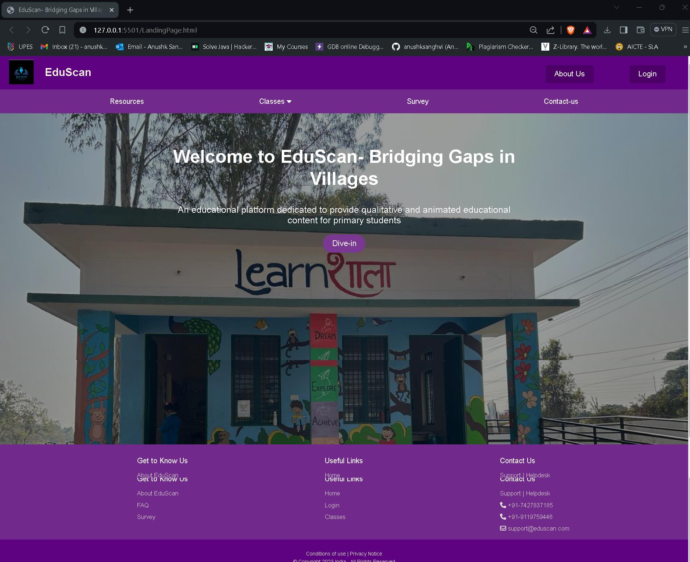

**Home-Page:**

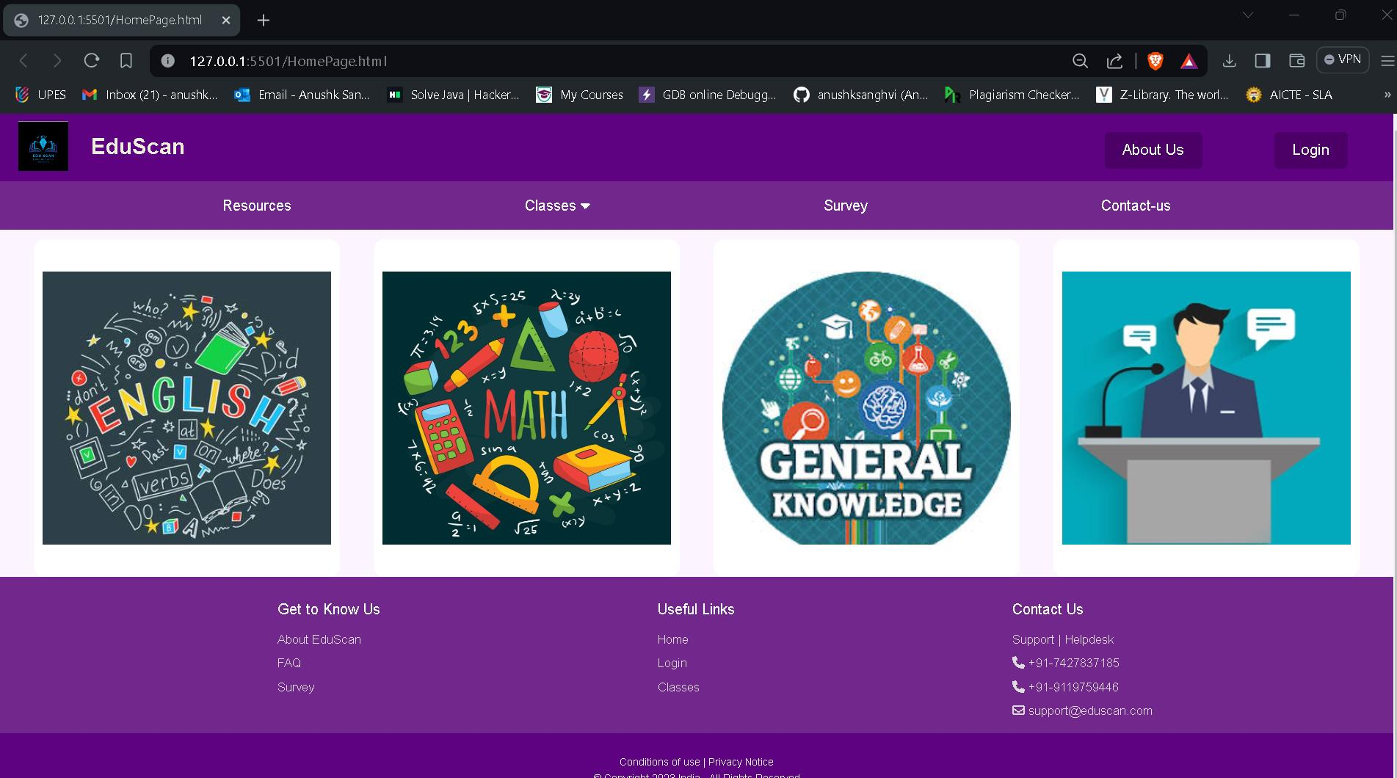

**About-Us Page:**

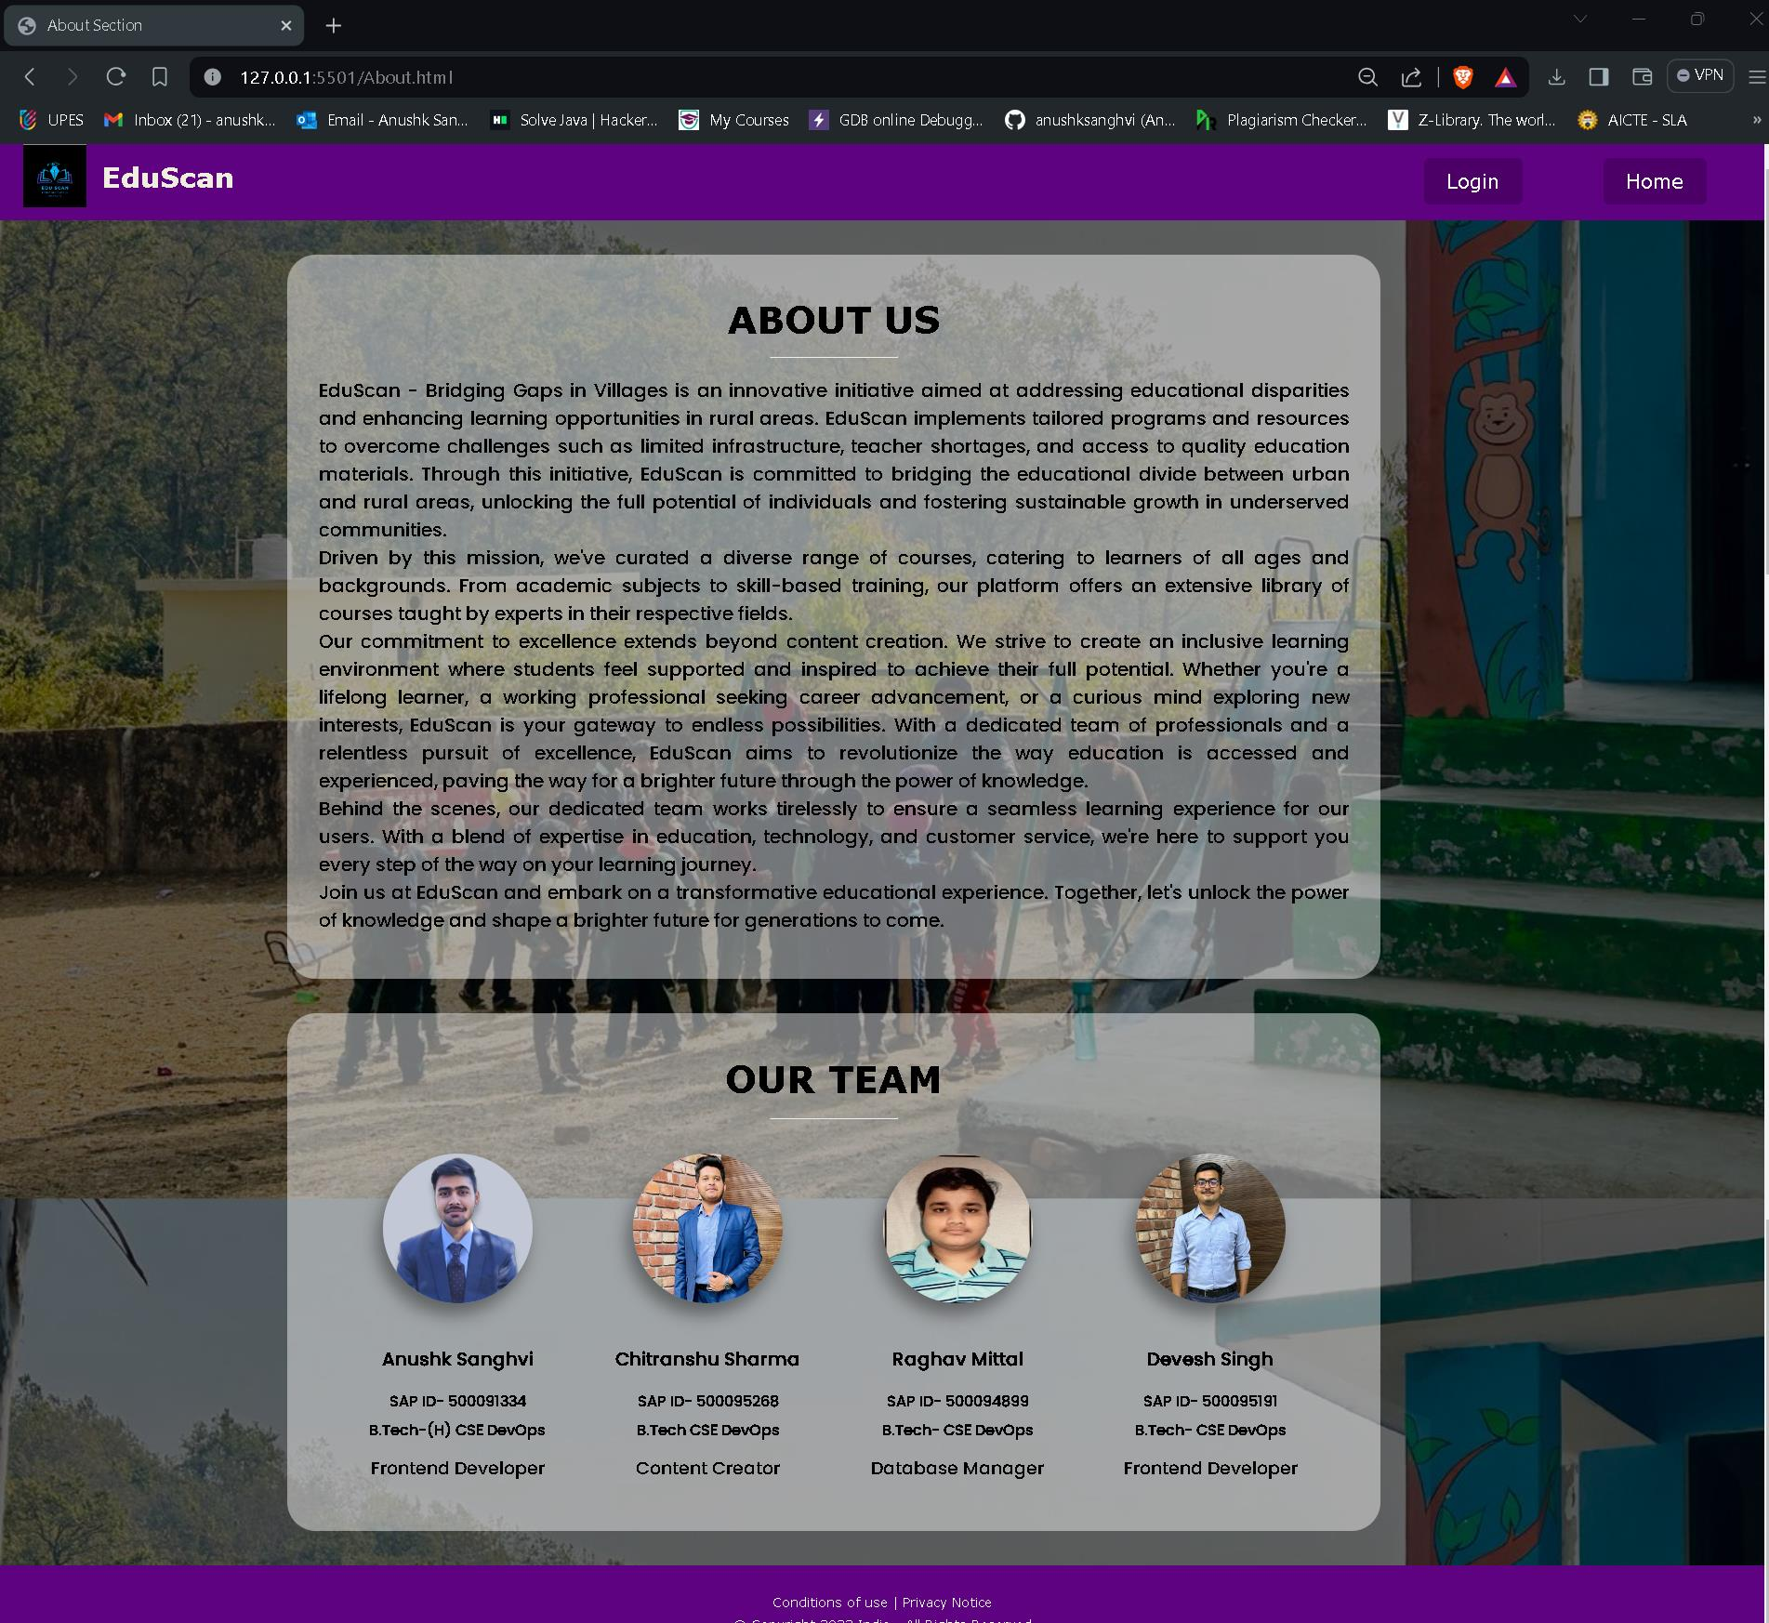

**FAQ Page:**

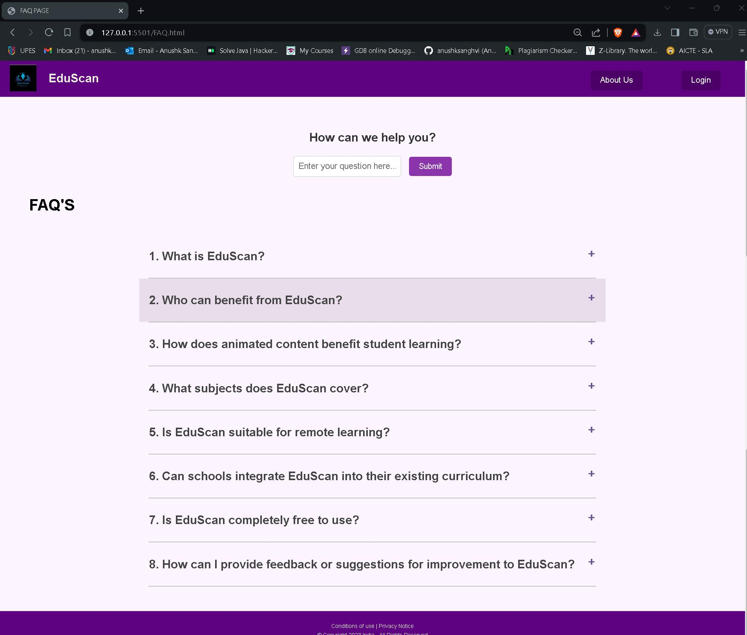

1. **Database Management:** Database management involves storing, retrieving, and managing data related to educational content, user accounts, survey responses, and other information within the EduScan platform.
2. **Backend Development:**

* Server-side programming: Utilizing languages like Node.js to handle backend operations.
* Backend development involves building the server-side logic, APIs, and database integration necessary to support the frontend functionality of the EduScan platform.